Daily Leetcode Problems
1. Detonate the Maximum Bombs - LeetCode
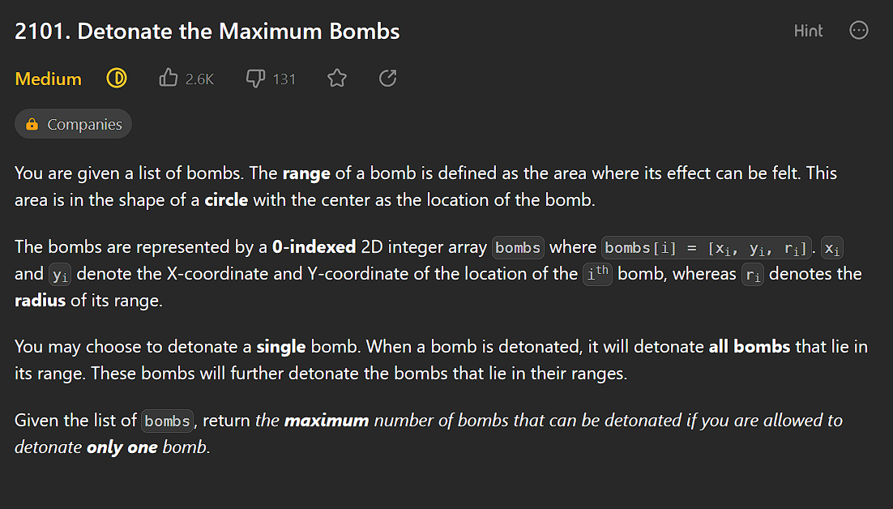
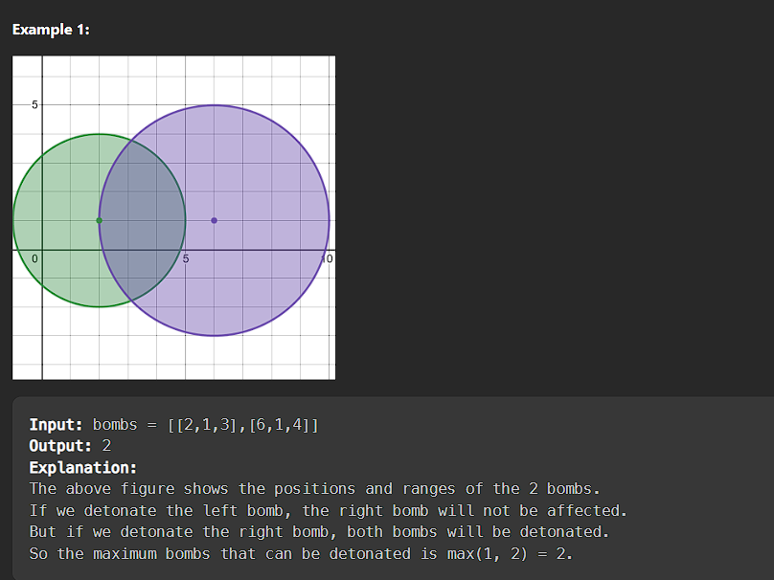

Logic: I first thought about using math to solve the problem by using Geometry concept like I will use a Radius range to solve the problem and if the circle radius point lie on that range then that is will be detonated but that is not a FULLY correct thing
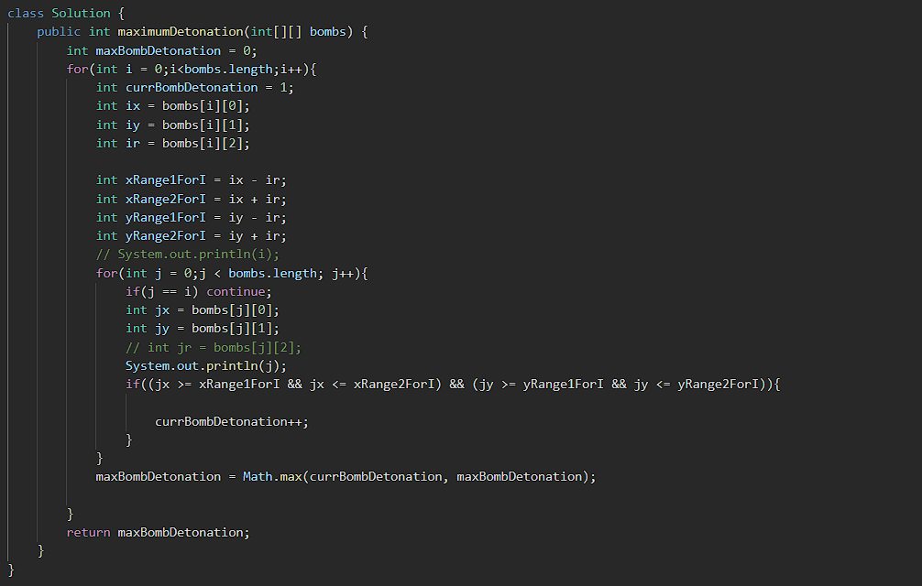
This logic fails then I go for the solution TAB
I found this video and I literally it clear all my doubts
Video: Detonate the Maximum Bombs - Leetcode 2101 - Java - YouTube
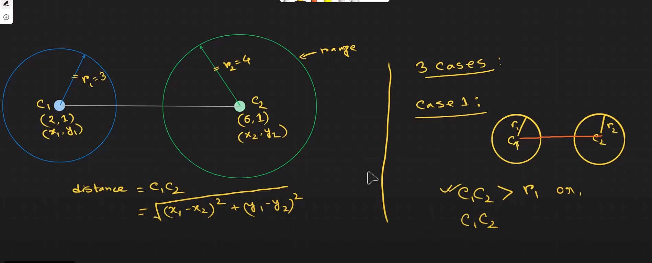
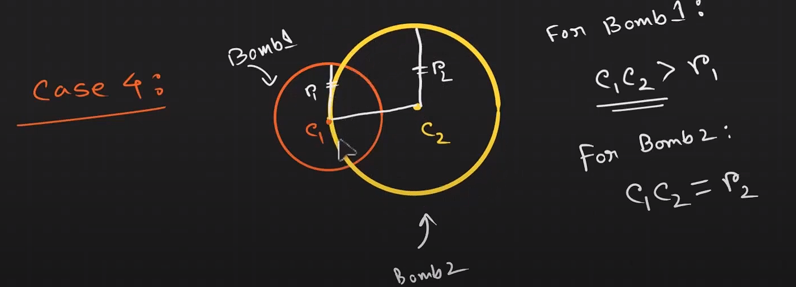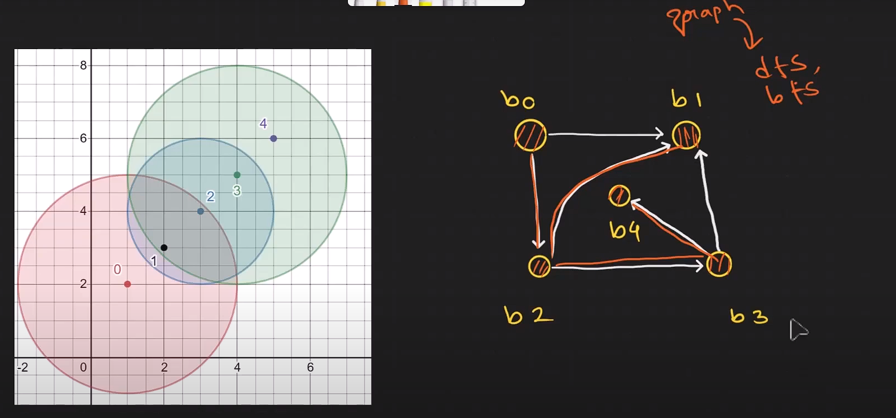

Code of mine( Done with the help of the video)
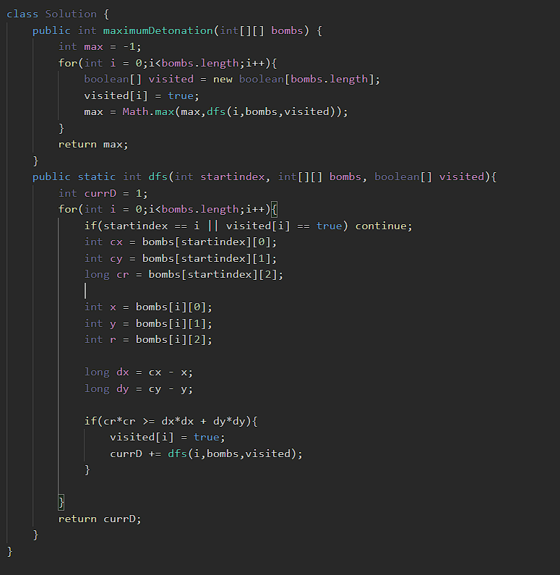
2. Peak Element
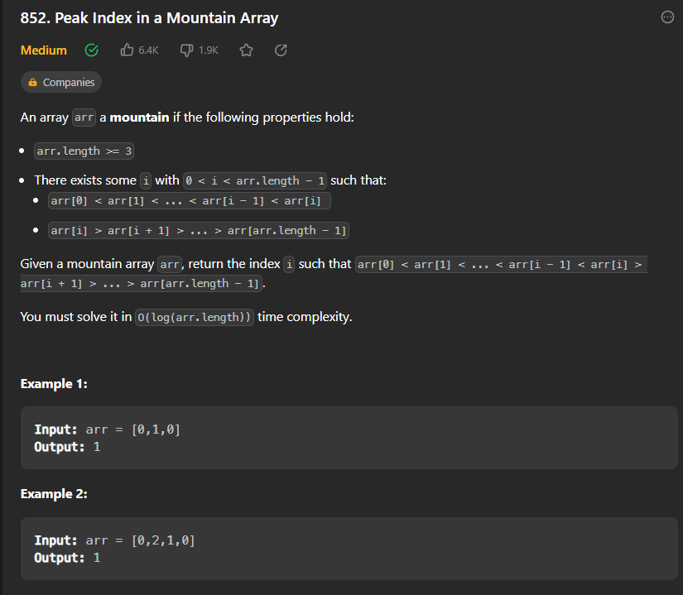
Logic: Simple binary search is used the difference is that both the side of the array is sorted except the peak element so the left side is sorted ascending order and the right side is sorted in descending order. So if I was in the left side then move to right side and vici verse until I found the peak element
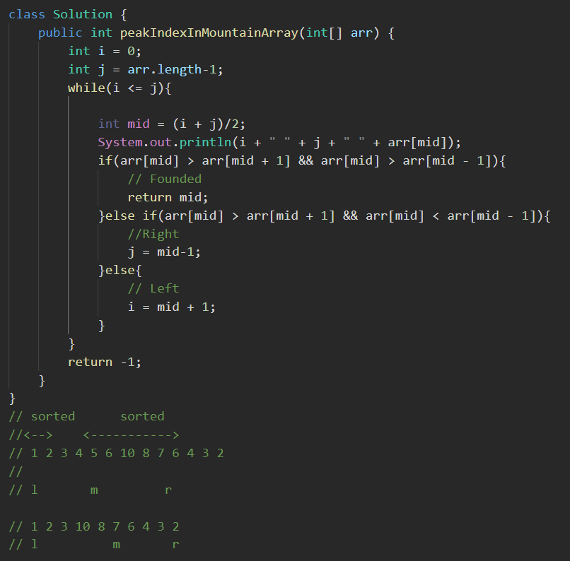

4. Check if it is possible to split array
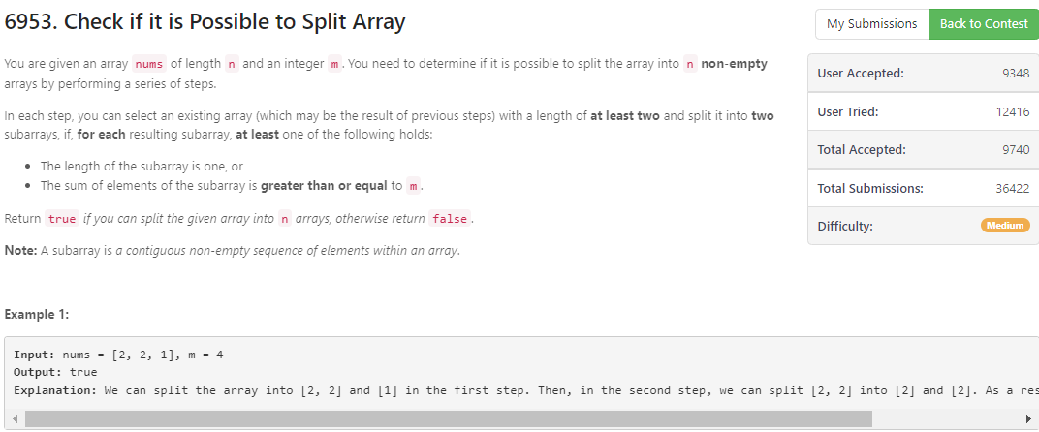
Logic: Here I used a recursion to solve this problem but I wont be able to submit it on the contest because I just get the recursive solution I wont be able to get it memorized so I watched the solution of it and thought I was a fool
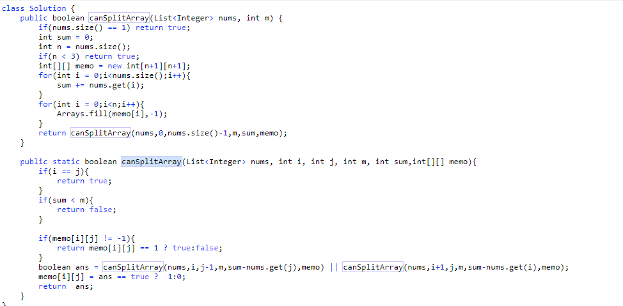

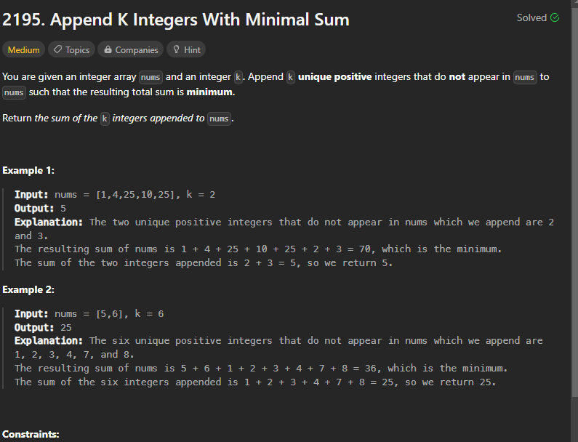
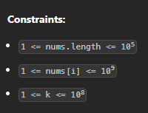
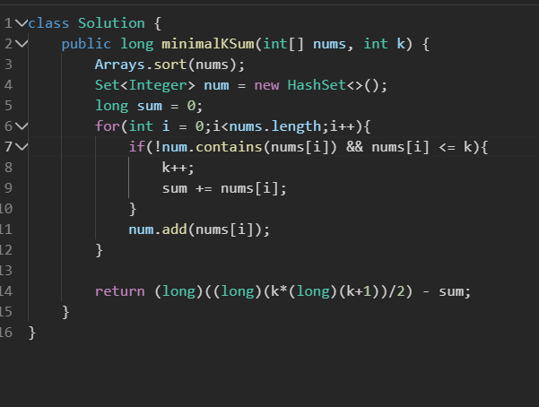

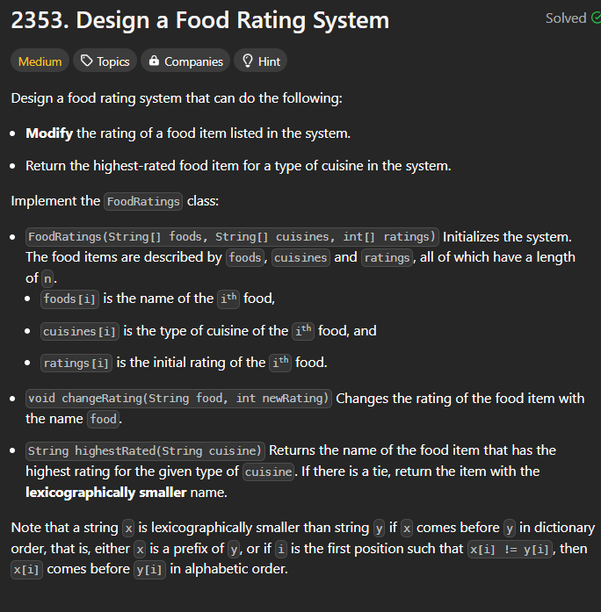
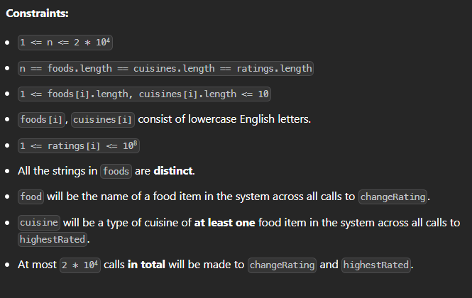
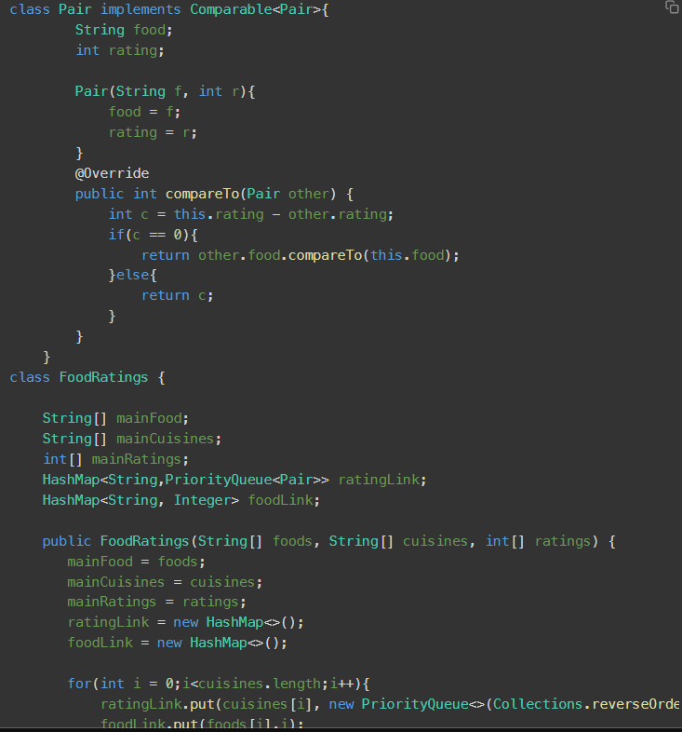
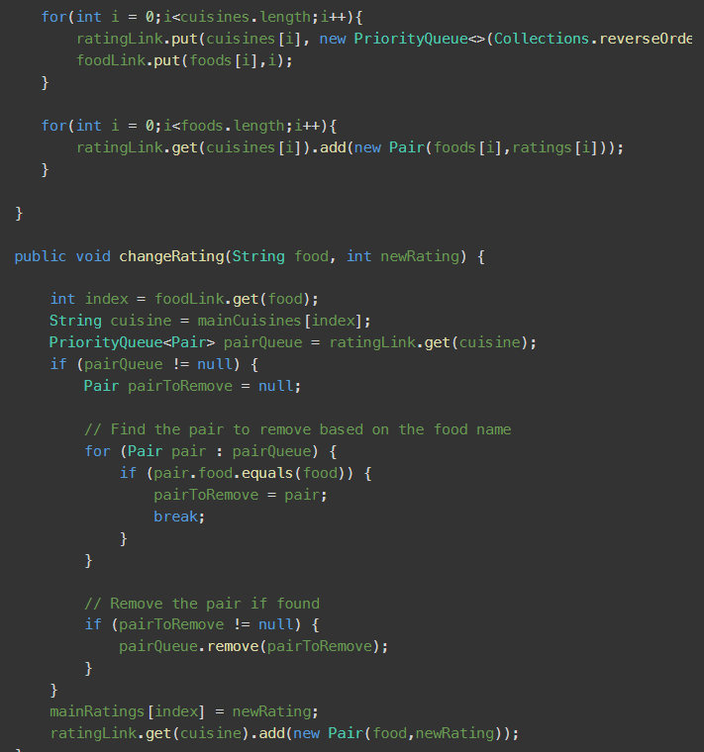
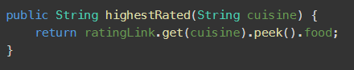
This was my code in which I got a TLE and I was confused at this point what I had done wrong so checking the solution after many retries then I got to know that My code was correct but the data structure I was using was not correct instead of using a PriorityQueue I should use a SortedSet<> which was new to me
So I copy pasted the code and analyse the code and got to know about it.
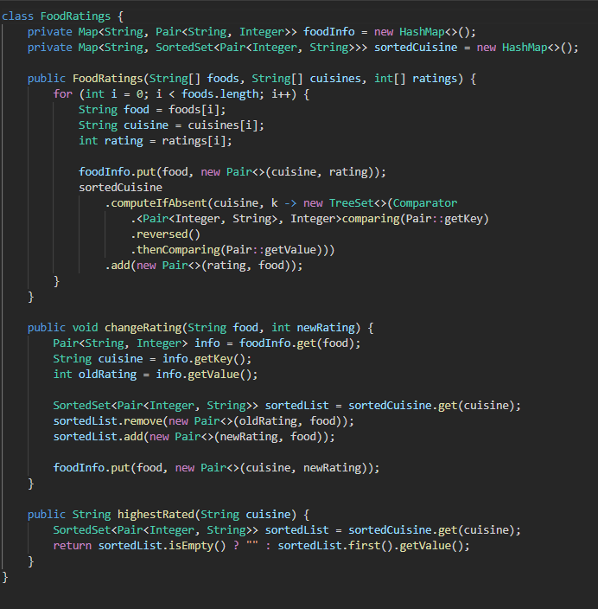
Let learn more about it using chatgpt
Main Methods:
- Comparator comparator(): Returns the comparator used to order the elements in the set, or null if the natural ordering is used.
- SortedSet<E> subSet(E fromElement, E toElement): Returns a view of the portion of the set whose elements range from fromElement, inclusive, to toElement, exclusive.
- SortedSet<E> headSet(E toElement): Returns a view of the portion of the set whose elements are less than toElement.
- SortedSet<E> tailSet(E fromElement): Returns a view of the portion of the set whose elements are greater than or equal to fromElement.
- E first(): Returns the first (lowest) element in the set.
- E last(): Returns the last (highest) element in the set.
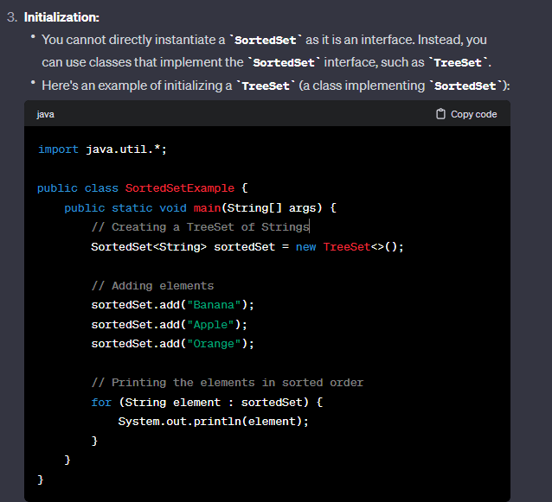

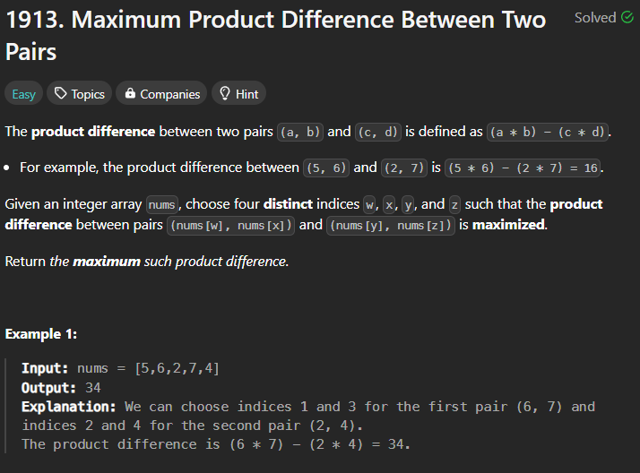
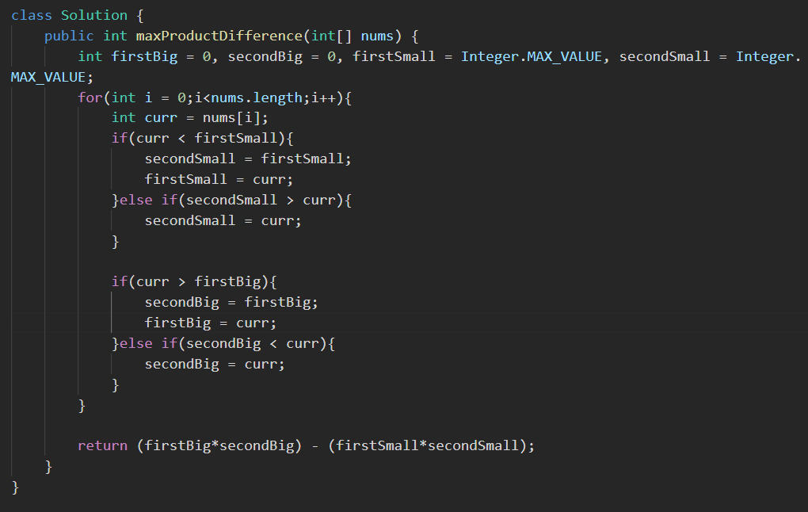Very Fabulous solution to find the firstlarge, secondlarge. and firstsmall and secondsmall.

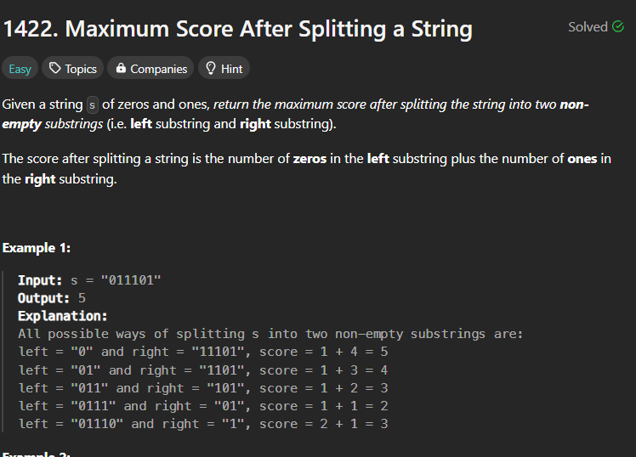

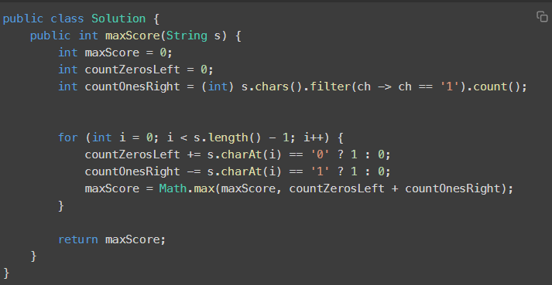
Best and very nice solution

